- Legal Risk
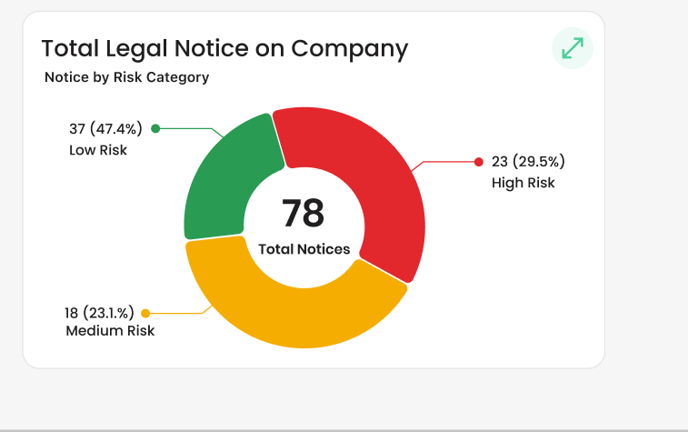

Total legal notice on company heading will be change as legal risk
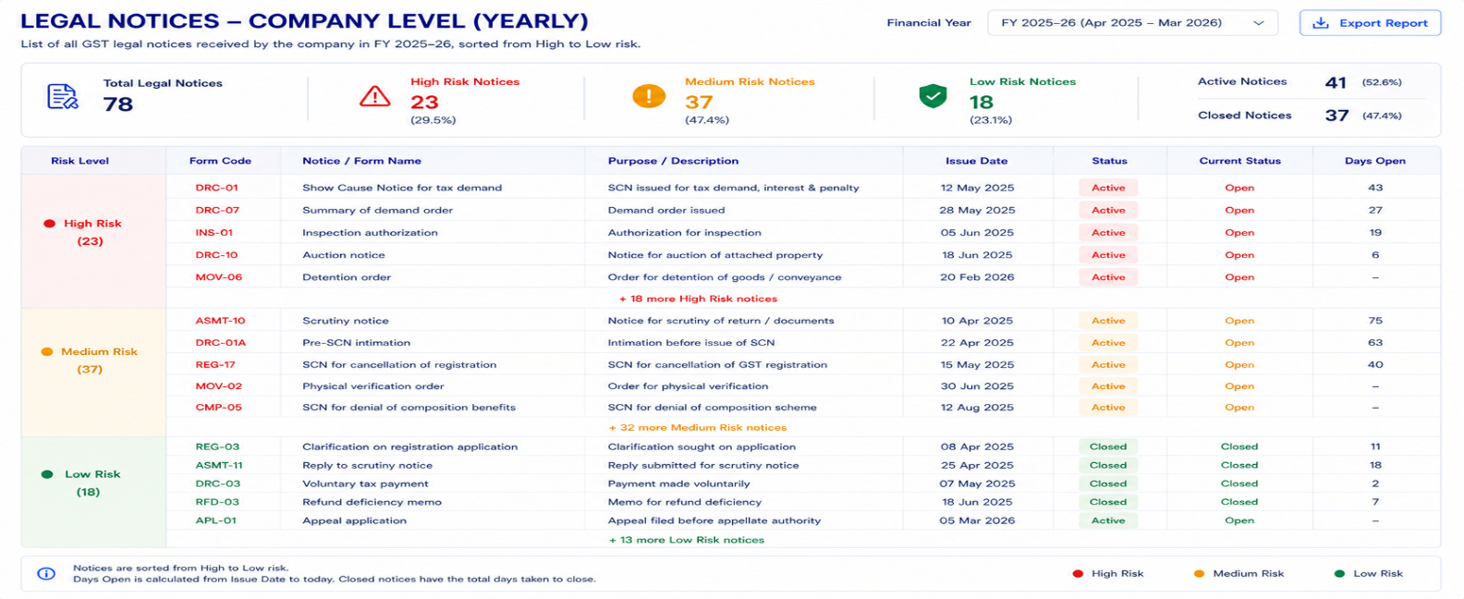

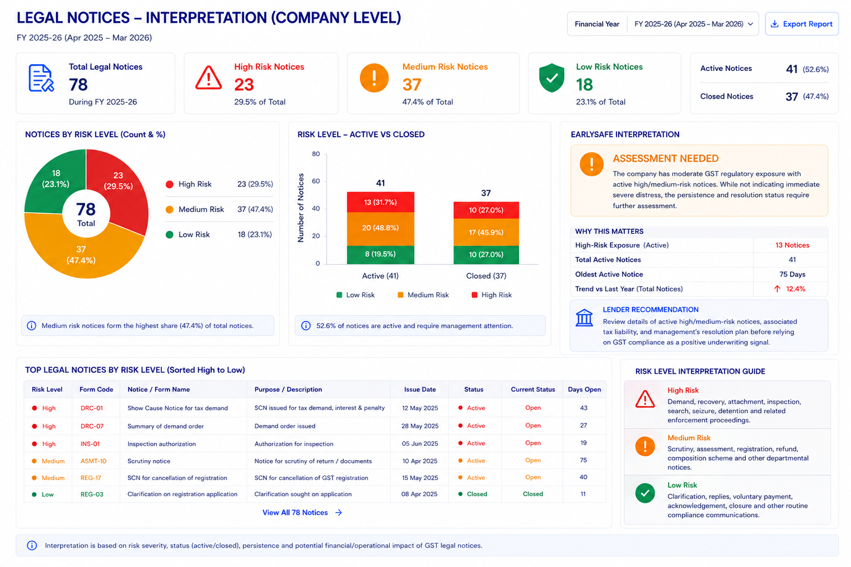

Remove quarterly and date filter

1. What is the chart for?
- This chart shows the current legal notice
- position of the company.
- It tells the user:
  - How many GST legal notices the company has received in a year.
  - How serious those notices are.
  - Whether the notices are still open or have been closed.
- The data will be taken from Legal Notice Details.

2. Data source
- Take legal notice data from legal notice detailed Notice type, Date of Issue, due date of reply for all GSTINs mapped to the Company PAN.
- Combine all GSTIN-level notices to create the company-level view.
- The main dashboard view will show the financial year.

3. Main chart — Total Legal Notices on Company
The main chart will be a donut chart.
It will show:
- Total Legal Notices
- Low Risk
- Medium Risk
- High Risk
The Centre of the donut should show the total number of notices.

4. Risk-wise calculation
Total Notices = Low Risk + Medium Risk + High Risk
For each category:
Risk % = Number of Notices in Risk Category ÷ Total Notices × 100

Low Risk Notices %
Low Risk Notice % = Number of Low-Risk Notices ÷ Total Notices × 100

Medium Risk Notices %
Medium Risk Notice % = Number of Medium Risk Notices ÷ Total Notices × 100

High Risk Notices %
High Risk Notice % = Number of High-Risk Notices ÷ Total Notices × 100

Overall check
Low Risk Notice % + Medium Risk Notice % + High Risk Notice % = 100%
These three percentages represent the complete risk distribution of the company's legal notices for the selected/current year.
The risk classification should come from the approved legal-notice risk mapping.

5. Risk categories

High Risk

Medium Risk

Low Risk

Will share separate file for this for detailed classification.

6. year view
- The chart should show notices issued during the financial year.
- The Issue Date should be used to determine which year the notice belongs to.
- Previous-year data should be retained in the backend for comparison.
- This allows the dashboard to show whether legal exposure is increasing or decreasing.

7. What happens when the user clicks the donut?
- When the user clicks High Risk, Medium Risk or Low Risk, the system should open the second view.
- The second view will contain the detailed legal notice table.

8. Second view — Tabular presentation
The table should show:
Field | Description
Risk Level | High / Medium / Low
Form Code | GST notice/form code
Notice / Form Name | Name of the notice
Purpose / Description | Reason for the notice
Issue Date | Date the notice was issued
Due date of reply | date

9. Table sorting
- Notices should be shown from High Risk → Medium Risk → Low Risk.
- Within each risk category, the user should be able to see the latest/current notices first.
- The table should support filtering by:
  - Risk Level
  - Form Code
  - Status
  - Current Status
  - Issue Date

13. EarlySafe Interpretation
The system should provide a short interpretation based on the actual data.
It should consider:
- Total notices
- Active notices
- High-risk active notices
- Age of active notices
- Current-year trend
- Resolution status
The interpretation should answer:
“What is the company's current legal/regulatory exposure?”

14. Important distinction
- A legal notice does not automatically mean delayed tax payment.
- The system should distinguish:
  - General compliance notices
  - Demand-related notices
  - Recovery-related notices
  - Registration notices
  - Assessment notices
  - Investigation/enforcement notices
  - Refund notices
  - Appeal-related matters
Only the relevant demand/recovery evidence should contribute to a tax-liability payment delay interpretation.

17. Missing data
- If legal notice information is missing for a GSTIN, it should not automatically be treated as zero notices.
- The backend should identify the GSTIN for which data is unavailable.
- Missing data should remain NULL.
- The operational data-fetching process can be used to retrieve the missing information.
. Data Handling Requirements
- Before creating the chart, the system should check whether data is available for all GSTINs under the PAN.
- If data is missing for any GSTIN, a small pop-up should appear.
- The pop-up should tell the user:
- Which GSTIN data is missing.
- For which period the data is missing.
- That the company's total turnover may not be complete.
- The pop-up should have two options:
- Fetch Data
- Continue Anyway
If the user clicks Fetch Data
- Take the user to the Operational Status / Data Fetching section.
- Show the GSTINs for which data is missing.
- Allow the system/user to fetch the missing data.
- After the data is successfully fetched, the revenue chart can be updated.
If the user clicks Continue Anyway
- Continue showing the revenue chart using whatever data is available.
- For the GSTIN where data is missing, keep the value as NULL.
- Do not treat missing data as ₹0.
- Clearly indicate that the displayed company turnover is based on available data and may be incomplete.
REST WILL SAME FOR THE LOAN LEVEL

19. In very simple words
The Legal Notice chart shows how many GST legal notices the company has received in the current year and how serious they are. All GSTINs under the PAN are combined. The first view gives a quick High, Medium and Low Risk summary through a donut chart. When the user clicks a risk category, the second view opens with a detailed table showing each notice, its date, risk level and current status.
Same will be calculated for laon Level
In interpretation we need to show the repeated notices issued on any organization in a year it should be seperately.

- GVA trend

Axis values will be in cr not in lakhs

Gross Value Added (GVA) Trend

1. What is the chart for?
- This chart shows three important things about the company's business activity:
  - Total Purchases
  - Total Revenue
  - Gross Value Added (GVA)
- It helps the user understand:
  - How much the company is purchasing.
  - How much revenue it is generating.
  - How much value the business is creating after considering purchases.

2. Which GST data will be used?
- Purchase-related data will be taken from GSTR-2B for all suplier across PAN.
- Revenue-related data will be taken from GSTR-3B for all suplier across PAN.
- The data should be collected for all GSTINs linked to the Company PAN.
- The GSTIN-level data should then be combined to create the company-level view.

3. Total Purchases
- Total Purchases (Company) = Σ Taxable Value of all Suppliers across all GSTINs under PAN
- This shows the company's total purchase value for the selected period.
- Purchase information will be taken from GSTR-2B.
- The result is shown as the blue bars.

4. Total Revenue
- Total revenue (Company) = Σ Taxable turnover Value across all GSTINs under PAN
- This shows the company's total taxable revenue/turnover for the selected period.
- Revenue information will be taken from GSTR-3B.
- Data from all GSTINs under the Primary PAN should be combined.
- The result is shown as the green bars.

5. Gross Value Added (GVA)
- GVA shows the value created by the business after considering its purchases.
- For this chart, GVA can be calculated using:
GVA = Total Revenue − Total Purchases
- GVA is shown as the yellow line.
- The backend should calculate GVA only after the purchase and revenue values have been aggregated at the company level.

6. GVA Margin =

Will be added in interpretation
- The chart can also show GVA Margin in the tooltip.
- It tells the user how much of the company's revenue remains as value added after considering purchases.

7. Half-yearly calculation
The current chart is showing half-yearly data.
- H1: April to September
- H2: October to March
For every half-year:
- Add the relevant purchase values from GSTR-2B.
- Add the relevant revenue values from GSTR-3B.
- Calculate GVA.
- Calculate GVA Margin.
If someone clicks on half yearly data it bifurcates into the respective months.

9. What will the user see?
- Blue bars: Total Purchases
- Green bars: Total Revenue
- Yellow line: Gross Value Added
- Left Y-axis: Purchase and Revenue it will be in Cr.
- Right Y-axis: GVA
- X-axis: Financial half-year

10. Percentage change
When the user moves over a particular half-year, the tooltip should show:
- Total Purchases
- % change in Purchases from previous half-year
- Total Revenue
- % change in Revenue from previous half-year
- GVA
- % change in GVA from previous half-year
- GVA Margin
- Change in GVA Margin
Percentage Change = (Current Half-Year Revenue − Previous Half-Year Revenue) / Previous Half-Year Revenue × 100

Positive percentage = revenue increased.
Negative percentage = revenue decreased.
First available period should not show an artificial 0% change because there is no previous period.

- Year to date

Percentage Change = (Current Year revenue − Previous Year revenue) / Previous Year revenue × 100

- Month to month

Percentage Change = (Current month revenue – Previous month revenue) / Previous month revenue × 100
This tells the user whether the company's total tax payment has increased or decreased compared with the previous period.
SAME CALCULATION FOR PURCHASE AS WELL AND GROSS VALUE ADDED AND %CHANGE
This allows the user to understand not just the value but whether the business is improving or weakening.

11. GVA Margin change
For GVA Margin, the change should ideally be shown in percentage points (pp) rather than percentage change.
For example:
Current GVA Margin: 33%
Previous GVA Margin: 31%
Show:
+2 pp
This is easier for the user to understand.

13. Click / Drill-down
When the user clicks on a particular period:
- Open the details for that selected period.
- Show the GSTIN-wise purchase and revenue contribution.
- The user should be able to understand which GSTIN contributed to the company's purchase and revenue.

14. Missing data handling
The system should check whether required data is available for all GSTINs.
If GSTR-2B or GSTR-3B data is missing for any GSTIN:
- Show a small pop-up.
- Show the GSTIN for which data is missing.
- Show the period for which it is missing.
- Give two options:
Fetch Data | Continue Anyway

15. If user clicks "Fetch Data"
- Redirect to Operational Status / Data Fetching.
- Show the GSTIN and missing data source.
- Allow the missing GSTR-2B/GSTR-3B data to be fetched.
- Once the data is available, the chart should be updated.

16. If user clicks "Continue Anyway"
- Continue showing the chart using available data.
- Missing values should remain NULL.
- Missing data must not be treated as zero.
- The system should indicate that the displayed result may be incomplete.

17. Important difference
- 0 = Actual reported value is zero.
- NULL = Data is missing/unavailable.
- NULL must not be converted to 0.
18. filter option should be visible in every chart on top right corner where the option will be in 2nd view
- Past 1 year
- Past 3 year
- Past 5 year
by selecting these the data will be visible as per the filter otherwise it will be remain as
And other filter to bifurcate the year as quaterly, half yearly, yearly
if the user select an option past 1 year then these option will be visible
- monthly
- quarterly
- half yearly
by selecting these the data will be visible as per the filter otherwise it will be remain same

REST WILL BE SAME FOR THE LOAN LEVEL

